PROBLEM SOLVING AND TESTING USING JAVA
WEEK 1 TASKS
(20/7/2026-25/7/2026)

NAME : NARENDAR M

VTUNO : 28192

Task 1: Access and print the element at a given index in an array.
Task 2: Search for a given element in a sorted array using Binary Search.
Task 3: Find the maximum element in an array of n integers.
Task 4: Find the Kth smallest element in an array.
Task 5: Print all possible pairs of elements from an array.
Task 6: Sum of even or odd digits.
Task 7: Nth Fibonacci.
Task 8: Check whether a number is a Palindrome.
Task 9: Sum of the last digits of two given numbers.

TASK : 1
package lambda_function; import java.util.Scanner; @FunctionalInterface interface ArrayElement { void display(int[] arr, int index);
}

public class TASK1 { public static void main(String[] args) {

Scanner sc = new Scanner(System.in);

System.out.print("Enter array size: "); int n = sc.nextInt();

int arr[] = new int[n];

System.out.println("Enter array elements:");
for (int i = 0; i < n; i++) { arr[i] = sc.nextInt();
}

System.out.print("Enter index: "); int index = sc.nextInt();

// Lambda Expression ArrayElement obj = (a, i) -> { if (i >= 0 && i < a.length)
System.out.println("Element = " + a[i]); else
System.out.println("Invalid Index, that index is not there");
};

obj.display(arr, index);

// sc.close();
}
}

OUTPUT:

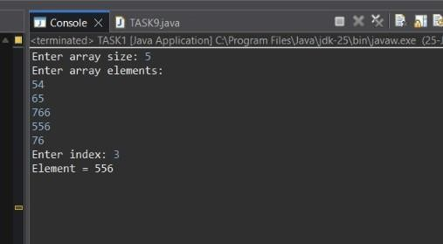

TASK : 2
package lambda_function; import java.util.Scanner; @FunctionalInterface interface BinarySearch { void search(int[] arr, int key);
}
public class TASK2 { public static void main(String[] args) {
Scanner sc = new Scanner(System.in); System.out.print("Enter array size: "); int n = sc.nextInt(); int arr[] = new int[n];
System.out.println("Enter sorted array elements:");
for (int i = 0; i < n; i++) { arr[i] = sc.nextInt();
}
System.out.print("Enter element to search: "); int key = sc.nextInt();
// Lambda Expression BinarySearch bs = (a, k) -> { int low = 0; int high = a.length - 1; boolean found = false; while (low <= high) { int mid = (low + high) / 2;

if (a[mid] == k) {
System.out.println("Element found at index " + mid); found = true; break;
} else if (a[mid] < k) { low = mid + 1;
} else { high = mid - 1;
}
}
if (!found) {
System.out.println("Element not found");
}
};
bs.search(arr, key); sc.close();
}
}
OUTPUT :
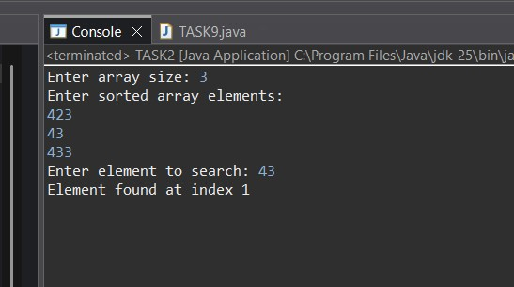

TASK : 3
package lambda_function; import java.util.Scanner; @FunctionalInterface interface Maximum {
void findMax(int[] arr);
}
public class TASK3 { public static void main(String[] args) {
Scanner sc = new Scanner(System.in); System.out.print("Enter array size: "); int n = sc.nextInt(); int arr[] = new int[n];
System.out.println("Enter array elements:");
for (int i = 0; i < n; i++) { arr[i] = sc.nextInt();
}
// Lambda Expression Maximum maxElement = (a) -> {
int max = a[0]; for (int i = 1; i < a.length; i++) { if (a[i] > max) { max = a[i];
}
}

System.out.println("Maximum Element = " + max); };
maxElement.findMax(arr); sc.close();
}
}

OUTPUT:
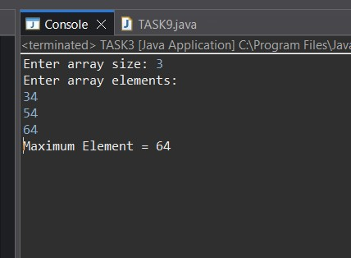

TASK : 4 package lambda_function; import java.util.Arrays; import java.util.Scanner; @FunctionalInterface interface KthSmallestElement { void findKthSmallest(int[] arr, int k);
}
public class TASK4 { public static void main(String[] args) {

Scanner sc = new Scanner(System.in);

System.out.print("Enter array size: "); int n = sc.nextInt();

int arr[] = new int[n];

System.out.println("Enter array elements:");
for (int i = 0; i < n; i++) { arr[i] = sc.nextInt();
}

System.out.print("Enter K: "); int k = sc.nextInt();

// Lambda Expression
KthSmallestElement obj = (a, key) -> { Arrays.sort(a);

if (key >= 1 && key <= a.length) {
System.out.println("Kth Smallest Element = " + a[key - 1]);
} else {
System.out.println("Invalid K");
}
};

obj.findKthSmallest(arr, k);

sc.close();
}
}

OUTPUT :
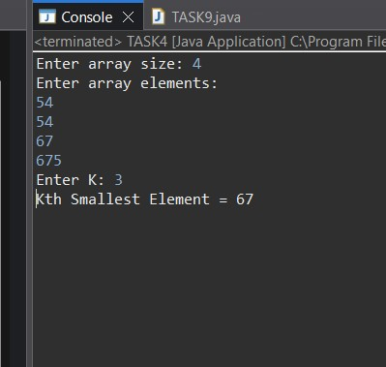
TASK : 5 package lambda_function; import java.util.Scanner; @FunctionalInterface interface ArrayPair { void printPairs(int[] arr);
}
public class TASK5 {

public static void main(String[] args) {

Scanner sc = new Scanner(System.in);

System.out.print("Enter array size: "); int n = sc.nextInt();

int arr[] = new int[n];

System.out.println("Enter array elements:");
for (int i = 0; i < n; i++) { arr[i] = sc.nextInt();
}

// Lambda Expression ArrayPair pair = (a) -> {
System.out.println("Pairs:");

for (int i = 0; i < a.length; i++) {
for (int j = i + 1; j < a.length; j++) {
System.out.println(a[i] + " " + a[j]);
}
}
};

pair.printPairs(arr);

sc.close();
}
}

OUTPUT :
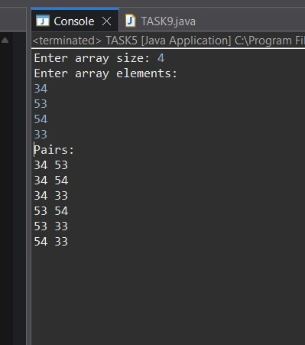

TASK : 6
import java.util.Scanner; @FunctionalInterface interface DigitSum { void findSum(int num, String choice);
}
public class TASK6 {
public static void main(String[] args) {
Scanner sc = new Scanner(System.in); System.out.print("Enter number: "); int num = sc.nextInt();
System.out.print("Enter choice (even/odd): ");
String choice = sc.next();

// Lambda Expression DigitSum ds = (number, ch) -> { int sum = 0; while (number > 0) { int digit = number % 10;

if (ch.equalsIgnoreCase("even") && digit % 2 == 0) { sum += digit;
}

if (ch.equalsIgnoreCase("odd") && digit % 2 != 0) { sum += digit;
}

number /= 10;
}

System.out.println("Sum = " + sum);
};

ds.findSum(num, choice);

sc.close();
}
}
OUTPUT :

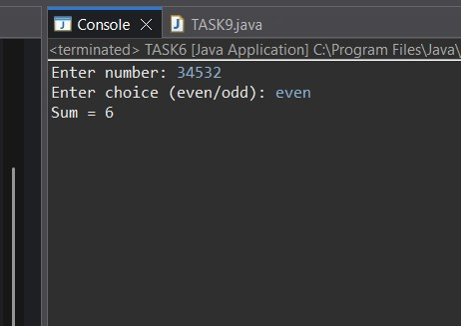

TASK : 7

import java.util.Scanner;

@FunctionalInterface interface FibonacciNumber { void findFibonacci(int n);
}

public class TASK7 {

public static void main(String[] args) {

Scanner sc = new Scanner(System.in);

System.out.print("Enter N: "); int n = sc.nextInt();

// Lambda Expression
FibonacciNumber fib = (num) -> {

int a = 0, b = 1;

if (num == 1) {
System.out.println("Nth Fibonacci = " + a);
}
else if (num == 2) {
System.out.println("Nth Fibonacci = " + b);
}
else { int c = 0;

for (int i = 3; i <= num; i++) { c = a + b; a = b; b = c;
}

System.out.println("Nth Fibonacci = " + c);
}
};
fib.findFibonacci(n); sc.close();
}
}
OUTPUT:
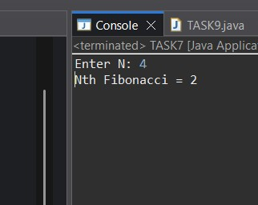

TASK : 8

import java.util.Scanner;

@FunctionalInterface interface Palindrome { void checkPalindrome(int num);
}

public class TASK8 {

public static void main(String[] args) {

Scanner sc = new Scanner(System.in);

System.out.print("Enter number: "); int num = sc.nextInt();

// Lambda Expression
Palindrome p = (number) -> {

int original = number; int reverse = 0;

while (number > 0) { int digit = number % 10; reverse = reverse * 10 + digit; number /= 10;
}

if (original == reverse)
System.out.println("Palindrome"); else
System.out.println("Not Palindrome");
};

p.checkPalindrome(num);

sc.close();
}
}
OUTPUT :
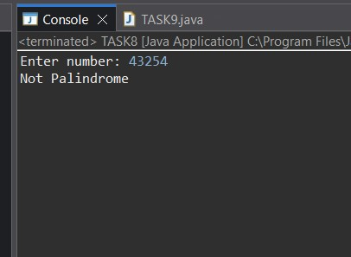

TASK : 9 package lambda_function;

import java.util.Scanner;

@FunctionalInterface interface LastDigitSum { void sumLastDigits(int a, int b);
}

public class TASK9 {

public static void main(String[] args) {

Scanner sc = new Scanner(System.in);

System.out.print("Enter first number: "); int a = sc.nextInt();

System.out.print("Enter second number: "); int b = sc.nextInt();

// Lambda Expression
LastDigitSum sum = (x, y) -> {

int last1 = x % 10; int last2 = y % 10; System.out.println("Sum of last digits = " + (last1 + last2));
};

sum.sumLastDigits(a, b);

sc.close();
}
}
OUTPUT :
